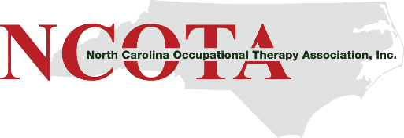

NCOTA Listening Sessions June 2020

Our shared purpose is to:
- Facilitate an open and honest dialogue
- Listen to learn others’ experiences to understand new and varied perspectives.
- Challenge ourselves by examining our own assumptions and beliefs.
- Demonstrate openness and respect. This is not a “debate” or a problem-solving discussion, but an opportunity to express and understand the multiple realities we experience as citizens and stakeholders.
- Be authentic. Only you can speak to your reality. You are never wrong for how you feel.
- Together, create an environment for healing.

We are guided by our principles of a trauma-informed response – where together, we seek to:
- Realize the widespread impact of trauma and understands potential paths for recovery;
- Recognize the signs and symptoms of trauma in those we serve, families, staff, and others;
- Respond by fully integrating knowledge about trauma into policies, procedures, and practices; and
- Seek to actively resist re-traumatization.

All sessions will use the same format. You are welcome to attend more than one, but the questions will be the same for each session. Please register using the link at https://www.ncota.org/diversity-equity-and-inclusion

