Hotels within 3 miles of WSSU FL Atkins building (1312 Cromartie Street)

The Historic Brookstown Inn
The Historic Brookstown Inn | Trademark Collection by Wyndham
200 Brookstown Ave, Winston-Salem, NC 27101
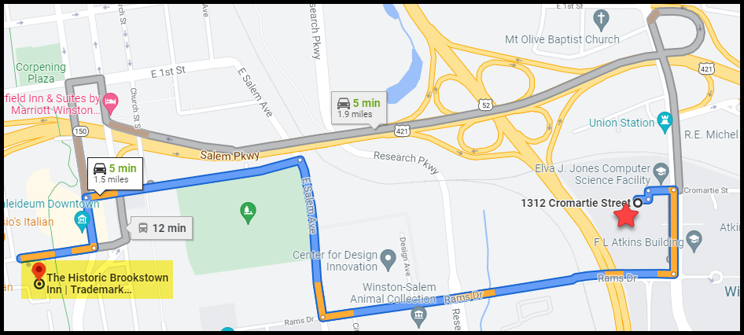
Estimated Travel time:1.5 miles About 5 min

Courtyard by Marriott Winston-Salem Downtown
640 West Fourth Street
Winston-Salem, North Carolina 27101
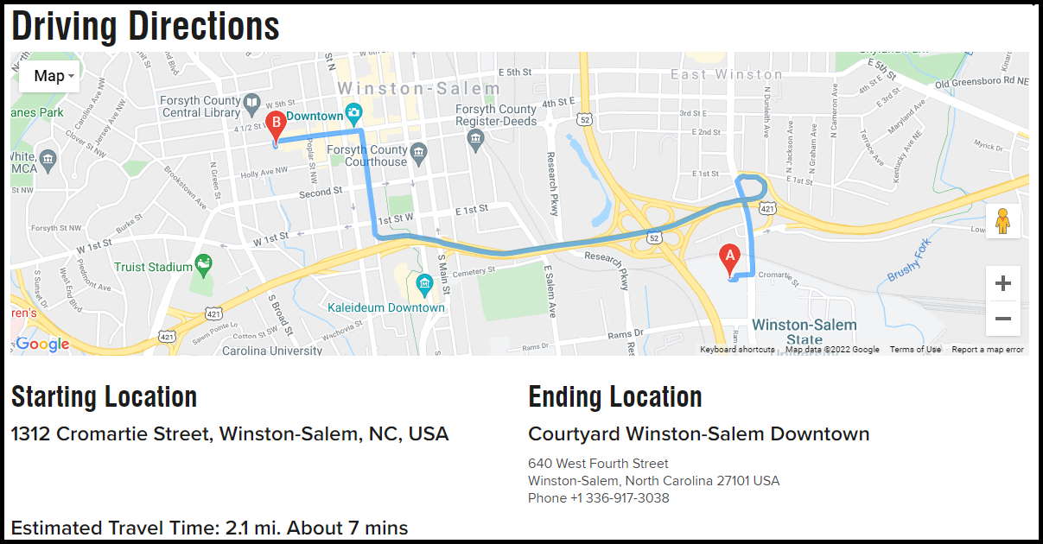

Embassy Suites by Hilton Winston Salem

460 N Cherry St

Winston-Salem, NC 27101
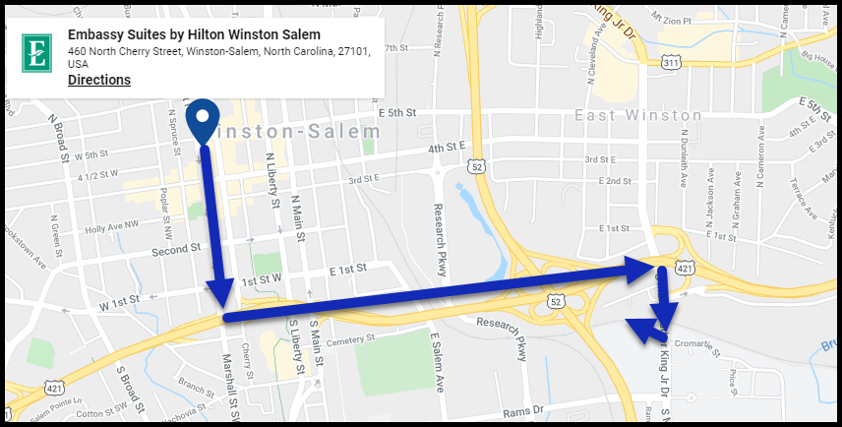
Estimated Travel time:1.9 miles About 5 min

Hampton Inn & Suites Winston-Salem Downtown

235 North Cherry Street

Winston-Salem, North Carolina 27101
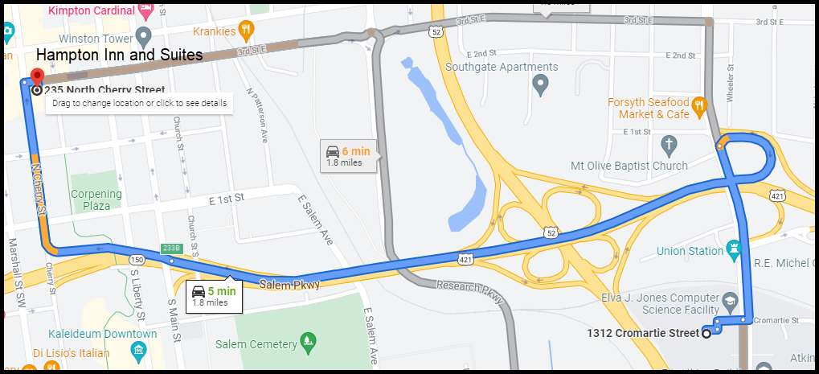
Fairfield Inn & Suites Winston-Salem Downtown
125 South Main Street
Winston-Salem, North Carolina 27101
